b/dvf]nf xfO8«f] OghL{ lnld6]8
Daramkhola Hydro Energy Limited
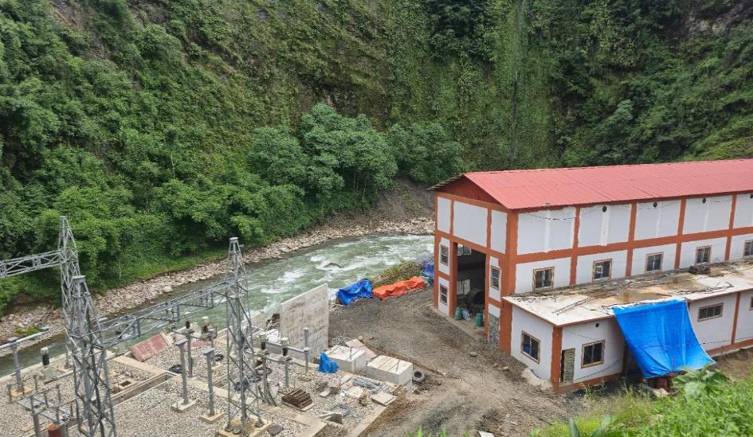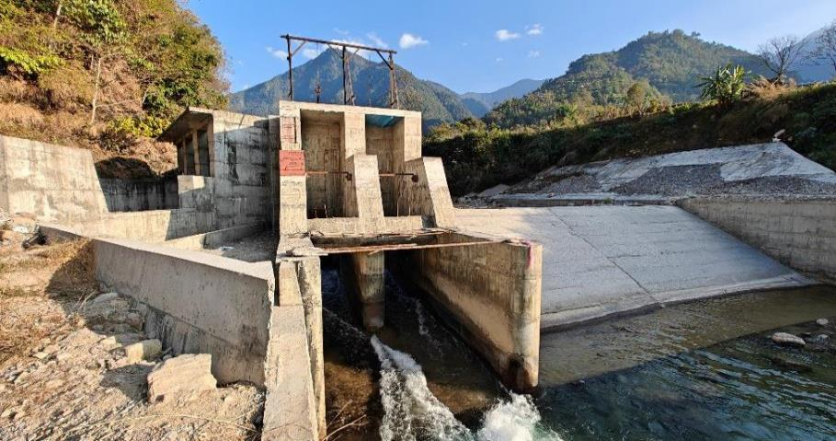

cf7f} / gjf} jflif{s ;fwf/0f;efsf] jflif{s k|ltj]bg
cf=j= @)&(÷*) / @)*)÷*!
b/dvf]nf xfO8«f] OghL{ lnld6]8
;Dks{ kmf]g g+=)!– $@$^)$%
Email M daramkholahydroenergy@gmail.com ,Web site Mdaramkholahydro.com
b/dvf]nf xfO8«f] OghL{ lnld6]8
xfn sfod ;~rfns ;ldlt
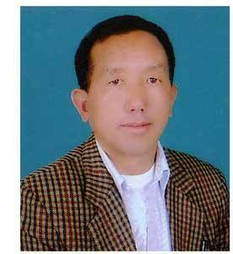  g/ axfb'/ k'g  cWoIf | 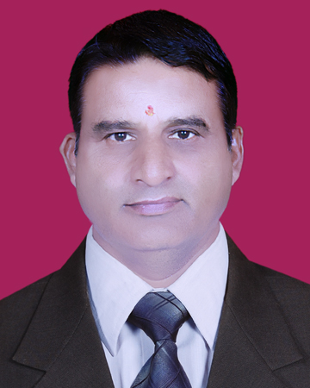  xl/ k|;fb ;fksf]6f  ;~rfns | 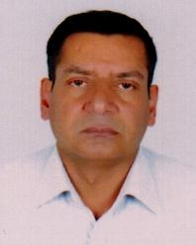  /fd k|;fb ;fksf]6f  ;~rfns
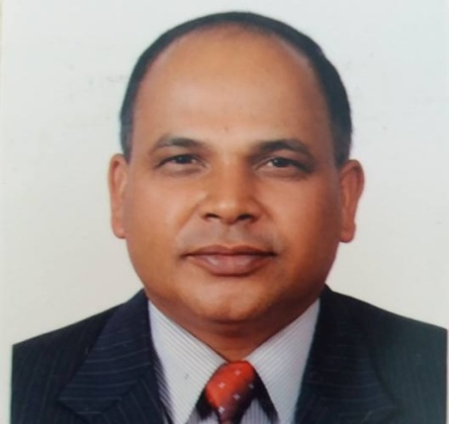  dfwj k|;fb v/]n  ;~rfns | 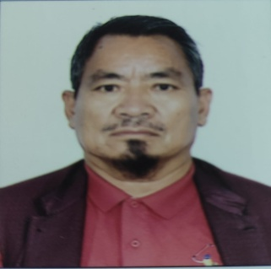  g/ axfb'/ 3lt{  ;~rfns | 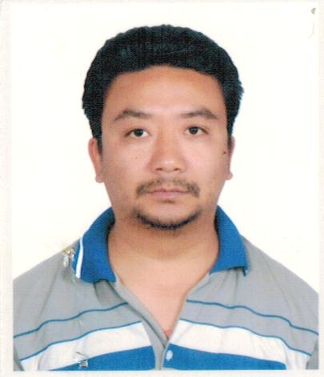  ?ksnfn >]i7  ;~rfns
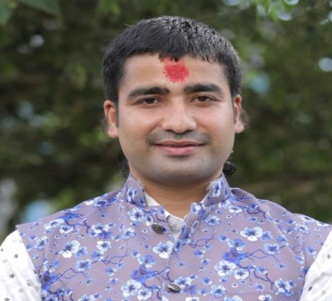  OGb|dl0f ;fksf]6f  ;~rfns | 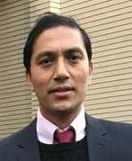  ;fnLs/fd ;fksf]6f  ;~rfns |   l6sf/fd v/]n  ;~rfns
  ejbQ ;'j]bL -ef]h]Gb|_  ;~rfns | 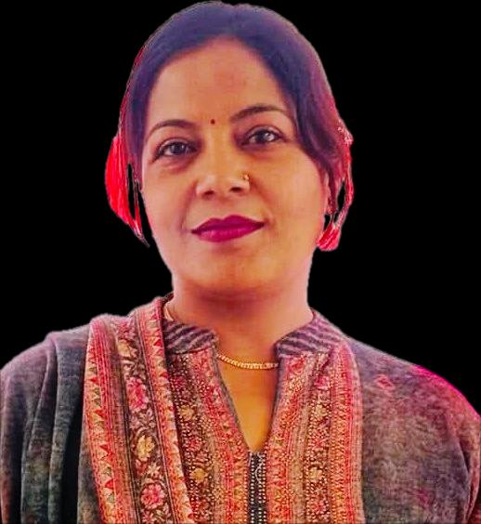  ufoqLb]lj zdf{  ;~rfns | 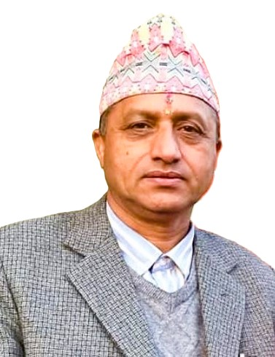  b]j/fh v/]n  s+kgL ;lrj

cg';'rL – ! kl/lzi6 -s_
bkmf %-$_ ;+u ;DalGwt
- sDkgL P]g, @)^# sf] bkmf &! sf] pkbkmf -#_ ;Fu ;DjlGwt_
k|ltlglw lgo'Qm ug]{ kmf/d -k|f]S;L kmf/d_
>L ;~rfns ;ldlt,
b/dvf]nf xfO8«f] Oglh{ lnld6]8
sf=d=g=kf= , ykfyln sf7df08f}+ .
ljifoM k|ltlglw -k|f]S;L_ lgo'Qm u/]sf] af/] .

=====================lhNnf============================ d=g=kf=÷p=d=g=kf=÷g=kf=÷uf=kf= j8f g= ======== a:g] d÷xfdL ==== ============= ========================n] To; sDkgLsf] @)*@ ;fn a}zfv dlxgf # ut] a'wjf/ x'g] jflif{s ;fwf/0f ;efdf :jo+ pkl:yt eO{ 5nkmn tyf lg0f{odf ;xefuL x'g g;Sg] ePsf]n] pQm ;efdf efu lng tyf dtbfg ug{sf nflu d]/f]÷xfd|f] k|ltlglwTj ul/ efu lng ===================== lhNnf ============================ d=g=kf=÷ p=d=g=kf=÷ g=kf=÷ uf=kf= j8f g= =========a:g] To; sDkgLsf z]o/ wgL ===========================================nfO{ d]/f]÷xfd|f] k|ltlglw dgf]gog ul/ k7fPsf] 5'÷5f}+ .

k|ltlglw x'g]sf] k|ltlglw lgo'Qm ug]{sf]
gfd M gfd M
b:tvt M b:tvt M
z]o/ wgL g+= z]o/ wgL g+=
z]o/ ;+Vof M z]o/ ;+Vof M
ldlt M ldlt M
b|i6Jo M of] lgj]bg ;fwf/0f;ef x'g' eGbf sDtLdf $* 306f cufj} sDkgLsf] k|wfg sfof{nodf k]z ul/;Sg' kg]{ 5 .
====================================================================================================================================================================================
b/dvf]nf xfO8«f] Oglh{ lnld6]8
sf=d=g=kf= , yfkfyln, sf7df08f
k|j]z kq
z]o/wgLsf] gfd M ================================================================
z]o/ wgL g+= =========================================================
s'n z]o/ ;+Vof M===================================
z]o/wgLsf] ;lx M ======================= ;ef sIfdf k|j]z ug{ of] k|j]z kq clgjfo{ ?kdf lnO{ cfpg'x'g cg'/f]w 5 . ==============================
sDkgL ;lrj

b/dvf]nf xfO8«f] OghL{ lnld6]8
ljifo–;"rL

ljj/0f k[i7
cf7f} / gjf} jflif{s ;fwf/0f;ef ;DaGwL ;"rgf÷hfgsf/L #
;~rfns ;ldltsf] tkm{af6 cWoIfsf] dGtJo $
Eff}lts tyf cfly{s cj:yf %
eflj gLtL tyf sfo{of]hg !#
;+:yfut ;fdflhs pQ/bfloTj !%
cGo !^

kl/of]hgf :ynsf] gS;f

cf7f} / gjf} jflif{s ;fwf/0f ;ef ;DjGwL ;"rgf
k|yd k6s k|sflzt ldtL M@)*!.!@.!!
bf]>f] k6s k|sflzt ldtL M@)*!.!@.#)
>L z]o/wgL dxfg'efjx? .
ldlt @)*! ;fn r}q dlxgfsf] % ut] a;]sf] o; b/dvf]nf xfO8«f] OghL{ lnld6]8sf] ;~rfns ;ldltsf] a}7sn] lg0f{o u/] cg';f/ o; lnld6]8 sDkgLsf] cf=j= @)&(÷@)*) / cf=j= @)*)÷@)*! sf] ;+o'Qm jflif{s ;fwf/0f ;ef lgDg lnlvt ldlt, ;do / :yfgdf lgDg ljifo pk/ 5nkmn tyf lg0f{ox? ug{sf] nflu a:g] ePsf] x'Fbf ;+:yfks tyf z]o/wgL dxfg'efjx?sf] hfgsf/Lsf] nflu of] ;"rgf k|sflzt ul/Psf] 5 .
!=aflif{s ;fwf/0f ;ef x'g] ldlt, ;do tyf :yfg M
aflif{s ;fwf/0f ;ef x'g] ldlt M @)*@.)!.# ut] a'wjf/
;do M lbp;f] !@M#) ah]
:yfg M sf7df08f}+ lhNnf sf=d=g=kf= j8f g+= @(, cgfdgu/, lsDrL /]i6'/]i6 P08 a}So"6 .
@= 5nkmnsf ljifo
-s_ ;fwf/0f k|:tfjx?
-!_ cfly{s jif{ cf=j= @)&(÷@)*) / cf=j= @)*)÷@)*! sf] ;~rfns ;ldltsf] jflif{s k|ltj]bg pk/ 5nkmn ul/ kfl/t ug{] .
-@_ n]vfkl/Ifssf] k|ltj]bg ;lxt cf=j= cf=j= @)&(÷@)*) / cf=j= @)*)÷@)*! sf] jf;nft,gfkmf gf]S;fg lx;fa tyf ;f]lx cjlwsf] gub k|jfx ljj/0f 5nkmn ul/ kfl/t ug{] .
-#_ sDkgL cfly{s jif{ @)*)÷)*! sf] nflu sDkgL P]g, @)^# sf] bkmf !!# cg';f/ sDkgL /lhi6«f/ sfof{noaf6 lgo'Qm n]vf kl/Ifssf] lgo'lQm / lghsf] kfl/>ldsnfO{ cg'df]bg ug]{ ;DjGwdf .
-$_ cfly{s jif{ @)*!÷)*@ sf] nflu sDkgL P]g, @)^# sf] bkmf !!! cg';f/ n]vf kl/Ifssf] lgo'lQm ug{] / lghsf] kfl/>lds tf]Sg] .
-%_ ;~rfns ;ldltsf] kbk'tL{ / :jtGq ;+rfnssf] lgo'QmL tyf cg'df]bg ;DaGwdf .
-^_ ljljw .
-v_ ljz]if k|:tfjx?
-!_ sDkgLsf] ;+rfns ;ldtLdf lgod @& adf]lhd ;+:yfks ;d'xsf] ;+rfns kbsf] lgjf{rg ug]{ ;DjGwdf .
-@_ sDkgLsf] /lhi6«8{ sfof{no kl/jt{g ug{ k|jGwkqsf] bkmf tyf / lgodfjnLsf] lgod @ / lgod @& df ;+zf]wg ug]{ ;DjGwdf .
-#_ IPO ;+u ;DaGwLt sDkgLsf] k|jGwkq / lgodfjnL tyf cGo sfg'gL ;+zf]wg ;DjlGwt lgsfox?af6 s'g} ;+zf]wg, km]/jbn jf yk36 ug{ s'g} ;'emfj jf lgb]{zg k|fKt ePdf ;f]xL adf]lhd cfjZos ;+zf]wg ug{ ;+rfns ;ldtLnfO{ clVtof/L k|bfg ug]{ ;DjGwdf .
-u_ ljljw
;+rfns ;ldltsf] cf1fn]
sDkgL ;lrj

jflif{s k|ltj]bg
;~rfns ;ldltsf] tkm{af6 cf7f} / gjf} jflif{s ;fwf/0f;efdf k|:t't
cf=j= @)&(÷)*) / @)*)÷*! sf] aflif{s k|ltj]bg


cfb/0fLo z]o/wgL dxfgefjx? Û b/dvf]nf xfO8«f] Oglh{ lnld6]8sf] cf7f} / gjf} jflif{s ;fwf/0f ;efdf pkl:yt ;Dk'0f{ z]o/wlg dxfg'efjx?, cfdlGqt dxfg'efjx?, ;+rfns ;ldltsf ;b:o Ho"x?, ;~Rff/sdL{ ;fyLx?, ;Nnfxsf/ tyf z'elrGts dxfg'efjx?df s{drf/L, sDkgLsf] ;+rfns ;ldltsf] tkm{af6 / d]/f] Joltmut tkm{af6 xflb{s :jfut tyf clejfbg ug{ rfxG5' . o; sDkgLsf] cf=j=@)&(÷)*) / cf=j=@)*)÷)*! sf] jflif{s k|ltj]bg nufot cfufdL sfo{sfnsf gLlt tyf sfo{qmd nufot jf;nft, gfkmf–gf]S;fg lx;fa, gub k|jfx ljj/0f tyf cfjZos cGo ljQLo ljj/0fx¿ o; ;efdf :jLs[ltsf nflu k|:t't ug]{ cg'dlt rfxG5' . k|:t't jflif{s k|ltj]bgsf] tyf ljQLo ljj/0f cWoog kZrft oxfFx¿af6 k|fKt x'g]/rgfTds ;'emfj, ;xof]u / ;b\efjn] sDkgLsf] efjL sfo{ of]hgf lgdf{0f tyf nIo k|flKtdf yk d2t k'Ug] 5 eGg] ljZjf; lnPsf 5f}+ .
sDkgLsf] ;+lIfKt kl/ro M
g]kfndf /x]sf] ckf/ hn>f]tsf] pkof]u u/L hnljB't cfof]hgfx?sf] klxrfg u/L ;+efJotf cWoog, lgdf{0f / ;+rfng ug]{ clek|fon] lghL If]qsf pBdLx? ldn]/ o; b/dvf]nf xfO{8«f] OghL{ lnld6]8, sDkgL P]g, @)^# adf]lhd ldlt @)&@ ;fn k'; )^ ut] g]kfn ;/sf/, sDkgL /lhi6«f/sf] sfof{nodf klAns lnld6]8 sDkgLsf] ¿kdf btf{ eO{ ;rf+ng ePsf] sDkgL xf] . ; sDkgLn] clxn] afUn'Ë lhNnf / u'NdL lhNnfsf] ;Ldfgf eO{ axg] b/dvf]nfdf (=^d]=jf= sf] hnljB't\ cfof]hgf ljsf; u/]/ lgdf{0f sfo{ ul//x]sf] 5 . xfn o; sDkgLdf *^# hgf ;+:yfks z]o/wgLx? /x]sf 5g\ . o; sDkgLsf ;+:yfks z]o/wgLx? ljB't, a}+s÷ljQLo If]q, :jf:Yo, z}lIfs If]q Pj+ Jofkf/÷Joj;fosf] ;fy} Joj:yfkg If]qdf nfdf] ;dob]lv bvn ePsf k|ltli7t JolQmTjx? /x]sf 5g\ .
cf7f} / gjf} jflif{s ;fwf/0f ;ef ;dIf pkl:yt eP/ jflif{s k|ltj]bg k|:t't ug{ kfpFbf dnfO{ v';L nfu]sf] 5 . o; cj;/df d ;Dk"0f{ z]o/wgL dxfg'efjx?, ko{j]Ifs, tyf sd{rf/Lx?df ;+rfns ;ldlt tyf d]/f] JolQmut tkm{af6 xflb{s :jfut clejfbg JoQm ub{5' . cfof]hgf lgdf{0fsf] k|utL tyf cfly{s ljj/0f tn pNn]v ul/Psf] 5 .

!= z]o/ k'FhL ;DaGwdf
sDkgLn] cfkm\gf] hf/L kF"hL dWo] ^#,%%,))) yfg z]o/ afktsf] k|lt z]o/ ?= !))÷– sf b/n] hDdf /sd ?=^#,%%,)),)))÷– sDkgLsf] ;+:yfks z]o/wgLx?af6 r'Qmf eO{;s]sf] / afFsL #(,%),))) yfg z]o/ ;fj{hlgs lgisf;gsf nflu g]kfn lwtf]kq jf]8{df ldtL @)*)÷)%÷)! df k|fylds ;fj{hlgs z]o/ lgZsfzg ug{sf nflu cfj]bg lbPsf] / xfn ;Dk'{0f sfg'gL k|s[of k'/f ul/ cGtLd :js[ltdf /x]sf]n] ;f] kZrft :yfgLo tyf ;j{;fwf/0fnfO{ hf/L ug]{5 . cfof]hgf k|efljt If]qsf afl;Gbfx?sf] nflu o; ljj/0f-kq dfkm{t !),#),%)) a/fa/sf] z]o/ lgisf;g x'g]5 / ;j{;fwf/0fsf] nflu 5'§\ofOPsf] @(,!(,%)) a/fa/sf] k"/} z]o/ lgisf;g ePkl5 sDkgLsf] r'Qmf k"FhL ?= !,)#,)%,)),)))÷—x'g]5 .

-s_ z]o/ k'FhL ;+/rf

ljj/0f | clws[t k'FhL  /sd ? | hf/L k'FhL  /sd ? | r'Qmf k'FhL  /sd ? | sDkgL /lhi6f/sf] sfo{nodf clen]v ePsf] ldlt
sDkgLsf] k'FhL ;+/rgf | %),)),)),))) | %),)),)),))) | &,!),)),))) | @)&@÷)(÷)^
sDkgLsf] k'FhL ;+/rgf | &%,)),)),))) | %^,)),)),))) | %!,^!,&*,))) | @)&^÷)@÷@(
xfn sDkgLsf] k'FhL ;+/rgf | !,)#,)%,)),))) | !,)#,)%,)),))) | ^#,%%,)),))) | @)&(÷!!÷!@

-v_ lgisfzg kl5sf]]] r'Qmf k'FhL

sDkgLsf] k|aGwkqsf] bkmf ^ df pNn]v eP cg';f/ :yfgLo tyf ;j{;fwf/0fx?df ;fwf/0f z]o/ lgisf;g u/L afF8kmfF8 u/] kZrft\ x'g] sDkgLsf] r'Qmf k"FhLsf] ;+/rgf b]xfo adf]lhd /x]sf] 5 M

qm=;+= | z]o/wgLx? | ;d"x | ;fwf/0f  z]o/ ;+Vof | r'Qmf /sd-?=_ | k"FhL  ;+/rgf | e'QmfgL  k|ltzt
! | ;+:yfks z]o/wgL | s | ^#,%%,))) | ?=^#,%%,)),)))÷– | ^!=^&% | Zftk|ltzt
@ | ;j{;fwf/0f z]o/wgL -:yfgLo_ | v | !),#),%)) | ?=!),#),%),)))÷– | !)% | afFsL
# | ;j{;fwf/0f z]o/wgL-;fd"lxs nufgL sf]if / sd{rf/Lx? ;d]t_ | v | @(,!(,%)) | ?=@(,!(,%),))) ÷– | @*=##% | afFsL
 | hDdf |  | !,)#,)%,))) | !,)#,)%,)),)))÷– | !))%

@= a}+s C0f / k"FhL ;+/rgf
-s_ nfut / C0f - a}+sn] :jLs[t u/] adf]lhd _
s|=;+= | ljj/0f | /sd :jLs[t | k|lt;t
! | C0f -a}+s_ | !,#%,)),)),)))÷– | ^&=(( Ü
@ | k'FhL -Equity _ ;+yfks | ^#,%%,)),))) ÷– | #@=)! Ü
# | k|f/lDes z]o/ lgZsf;g af6 k|fKt | #(,%),)),)))÷–
 | s'n nfut | @,#*,)%,)),)))÷– | !)) Ü

-v_ s"n C0f - a}s C0f _
s|=;+= | ljj/0f | /sd ?  :jLs[t | k|lt;t | cfiff0f d;fGt ;Dd -@)*!_ | k|lt;t
! | g]kfn OGkm|fO:6Sr/ a}s ln | !,!),)),)),)))÷– | &*=%&Ü | (#,*(,!&,#&%÷– | *( Ü
@ | Pg= cfO{= l;= Pl;of a}s ln= | #),)),)),)))÷– | @!=$@ Ü | @(,$#,$),&(&÷– | (* Ü
 | s'n nfut | !,$),)),)),)))÷– | !)) Ü | !,@#,#@,%*,!&@ ÷– | (! Ü

-u_ cGo ;'ljwf
s|=;+= | ljj/0f | /sd
! | Bridge Gap Loan | $),)),)),)))÷–
@ | W.C. Loan | ^,)),)),)))÷–
# | L/C Facility | &%,)),)),)))÷–
$ | IPO Agnaist Loan (Laxmi Sunrise Bank) | #%,)),)),))) ÷–
-k|f/lDes z]o/ lgZsf;g af6 k|fKt ?=#%s/f]8 C0f lkmtf{ ug]]{ k|of]u ug]{ ._
- C0f ltg]{ cjlw !@ aif{ Jofkfl/s pTkfbg ePsf] ldlt jf6 csf]{ q}dfl;s jf6 C0f e'Qmflg ;'? x'g]5 .
#= ljlQo cj:yf
cfly{s aif{ @)&(÷*) / cf=j @)*)÷*! sf] jf;nft, Gffkmf gf]S;fg lx;fa / gub k|jfx ljj/0f lgDg cg';f/ 5 .
jf;nft
 | ljj/0f | jf:tljs -?= _
 |  | 2078/79 | 2079/80 | 2080/81
 | ;DklQ
 | u}/ rfn' ;DklQ
 | ;DklQ, d]lzg/L tyf pks/0f | 351,534 | 263,651 | 197,738
 | kF"hLut sfddf k|ult | - | - | 2,464,494,143
 | cd"t{ ;DklQ | 1,230,975,555 | 1,931,166,473 | -
 | :ylut s/ ;Dklt | - | - | -
 | cGo u}/ rfn' ;DklQ | - | - | 1,235,698
 | hDdf u}/ rfn' ;DklQ | 1,231,327,089 | 1,931,430,124 | 2,465,927,579
 | rfn' ;DklQ
 | gub jf ;f] ;/x | 5,464,962 | 4,243,406 | 826,481
 | lhG;L ;fdu|L | - | - | -
 | cGo rfn' ;DklQ | 109,827,102 | 94,378,143 | 4,153,000
 | rfn' ljQLo ;DklQ | 37,365,000 | 5,638,698 | 67,310,107
 | hDdf rfn' ;DklQ | 152,657,064 | 104,260,247 | 72,289,588
 | hDdf ;DklQ | 1,383,984,153 | 2,035,690,371 | 2,538,217,167
 | kF"hL tyf bfloTjx?
 | k"FhL
 | r'Qmf k"FhL | 516,187,000 | 635,500,000 | 635,500,000
 | z]o/ P8efG; | 81,960,283 | - | -
 | hu]8f tyf sf]if | 139,646,534 | 214,622,368 | 272,052,772
 | hDdf kF"hL | 737,793,817 | 850,122,368 | 907,552,772
 | bfloTj
 | u}/ rfn' bfloTj
 | shf{ tyf pwf/f] | -
 | lb3sflng C0f tyf shf{ | 550,291,722 | 1,092,022,344 | 1,213,998,172
 | hDdf u}/ rfn' bfloTj | 550,291,722 | 1,092,022,344 | 1,213,998,172
 | rfn' bfloTj
 | sd{rf/L nfe bfloTj | 3,818,425 | 8,287,959 | 8,620,976
 | cNksflng C0f tyf shf{ | - | 35,000,000 | 319,464,074
 | 6«]8 / cGo bfloTj | 92,080,189 | 50,257,699 | 88,581,172
 | s/ bfloTj | - | - | -
 | hDdf rfn' bfloTj | 95,898,614 | 93,545,658 | 416,666,222
 | hDdf bfloTj | 646,190,336 | 1,185,568,002 | 1,630,664,394
 | hDdf kF"hL tyf bfloTjx? | 1,383,984,153 | 2,035,690,370 | 2,538,217,167
 | Gffkmf gf]S;fg lx;fa
 | ljj/0f | jf:tljs -?= _
 |  | 2078/79 | 2079/80 | 2080/81
 | laqmL cfDbfgL | 75,053,982 | 81,648,507 | -
 | laqmL cfDbfgL (IFRIC 12) |  |  | 62,190,955
 | laqmL nfut | - | - | -
 | s"n gfkmf | 75,053,982 | 81,648,507 | 62,190,955
 | cGo cfDbfgL ÷ -vr{_ | - | - | 249
 | s"n gfkmf | 75,053,982 | 81,648,507 | 62,191,204
 | k|zf;lgs vr{ | 684,897 | 2,380,407 | 1,189,003
 | sd{rf/L vr{ | 964,821 | 1,122,500 | 1,122,500
 | d"NoX|f; / kl/zf]wg | 104,276 | 94,766 | 72,796
 | ;Grfng gfkmf | 73,299,988 | 78,050,834 | 59,806,905
 | z'4 ljQLo nfut | - | - | -
 | sd{rf/L jf]gz cl3sf] gfkmf | 73,299,988 | 78,050,834 | 59,806,905
 | sd{rf/L jf]gz Joj:yf | - | - | -
 | s/ cl3sf] gfkmf | 73,299,988 | 78,050,834 | 59,806,905
 | rfn'jif{sf] cfos/ vr{ | - | - | -
 | cl3Nnf] jif{sf] cfos/ vr{ | - | - | -
 | :yug s/ cfDbfgL | - | - | -
 | o; jif{sf] gfkmf | 73,299,988 | 78,050,834 | 59,806,905
 | cGo lj:t[t cfDbfgL
 | ljj/0f | jf:tljs -?= _
 |  | 2078/79 | 2079/80 | 2080/81
 | gfkmf÷-gf]S;fg_ lx;favftf cg';f/sf] gfkmf÷-gf]S;fg_ | 73,299,988 | 78,050,834 | 59,806,905
 | cGo lj:t[t cfDbfgL | - | - | -
 | s= gfkmf÷-gf]S;fg_ lx;favftfdf pNn]v ug{' gkg]{ lzif{sx?
 | O{SjL6L z]o/df ul/Psf] nufgLaf6 ePsf] gfkmf÷-gf]S;fg_ plrt d"Nodf dfkg | - | - | -
 | k"0f{ d'Nof°gaf6 gfkmf÷-gf]S;fg_ | - | - | -
 | sd{rf/L nfe of]hgfdf PSr'l/on gfkmf÷-gf]S;fg_ | - | - | -
 | dfly pNn]lvt lzif{sx?df nfUg] s/ | - | - | -
 | s'n gfkmf÷-gf]S;fg_ lx;favftfdf pNn]v ug{' gkg]{ cGo lj:t[t cfDbfgL | - | - | -
 | gub k|jfx x]h gfkmf÷-gf]S;fg_ | - | - | -
 | ljb]zL ;+rfngsf] ljQLo ;DklQaf6 ;6xL gfkmf÷-gf]S;fg_ | - | - | -
 | dfly pNn]lvt lzif{sx?df nfUg] s/ | - | - | -
 | gfkmf÷-gf]S;fg_ df k'Mg jlu{s/0f | - | - | -
 | s'n gfkmf÷-gf]S;fg_ lx;favftfdf pNn]v ug{' kg]{ cGo lj:t[t cfDbfgL | - | - | -
 | o; cf=j sf] s'n cGo lj:t[t cfDbfgL | 73,299,988 | 78,050,834 | 59,806,905
 | gub k|jfx ljj/0f
 | ljj/0f | jf:tljs
 |  | 2078/79 | 2079/80 | 2080/81
 | ;~rfng ultljlwaf6 gub k|jfx
 | cfos/ cl3sf] v'b gfkmf | 73,299,988 | 78,050,834 | 59,806,905
 | ;dfof]hg M
 | ;DkQLsf] ljqmLaf6 3f6f | - | - | -
 | IFRIC – 12 cg';f/sf] gfkmf÷-gf]S;fg_ | (75,053,982) | (81,648,507) | (62,190,955)
 | x|f;s6L vr{ | 104,276 | 94,765 | 72,796
 | ;"rLdf kl/jt{g | - | - | -
 | cGo rfn' ;DklQdf kl/jt{g | (3,447,481) | 47,175,261 | 27,318,035
 | cGo bfloTjdf kl/jt{g | 61,706,454 | (2,352,956) | 230,804,439
 | ;+rfngaf6 s'n gub k|fKt | 56,609,255 | 41,319,397 | 255,811,220
 | ljlQo ultljlwaf6 gub k|jfx
 | z]o/ kF"hLdf kl/j{tg | - | 119,313,000 | -
 | clu|d sfndf kl/jt{g | 43,931,280 | (81,960,283) | -
 | bL3{sfnLg bfloTjdf kl/jt{g | 430,291,722 | 541,730,622 | 214,291,953
 | z]o/ hf/L vr{ | - | (3,075,000) | (2,376,501)
 | nfef+z e'QfgL | - | - | -
 | ljlQo ultljlwaf6 v''b gub k|jfx | 474,223,002 | 576,008,339 | 211,915,452
 | nufgL ultljlwaf6 gub k|jfx
 | 7f]; l:y/ ;DklQdf kl/jt{g | (87,000) | - | -
 | lgdf{0fflwg{ ;DklQdf sdL÷-j[l4_ | (568,590,770) | (618,549,293) | -
 | CWIP sdL÷-j[l4_ | - | - | (471,143,597)
 | nufgL ultljlwaf6 v'b gub k|jfx | (568,677,770) | (618,549,293) | (471,143,597)
 | gub k|jfxdf v'b a[l4÷-sdL_ | (37,845,513) | (1,221,557) | (3,416,926)
 | jif{sf] z'?df ePsf] gub | 43,310,475 | 5,464,962 | 4,243,406
 | jif{sf] clGtddf ePsf] gub | 5,464,962 | 4,243,405 | 826,480
sDkgLsf] ljlQo kl/;'rs M -xfn j}s jf6 :jLs[t jh]6 cg';f/ _
cfof]hgfsf] nfut lgdf{0f cjlwsf] Aofh afx]s | ?=@)& s/f]8
cfof]hgfsf] nfut lgdf{0f cjlwsf] Aofh ;lxt | ?=@#* s/f]8
cfof]hgfsf] ;fwf/0f nufgL lkmtf{ x'g] cjlw(Pay Back Period) | (=& aif{
cfof]hgfsf] l8isfpG6df nufgL lkmtf{ x'g] cjlw(Discounted Pay Back Period) | !&=&* aif{
Internal Rate of Return of Project(IRR) | (=(@Ü
Equity IRR | !$=)@Ü
z]owgL ;+Vof | *^#
k|lt z]o/ cfDbfgL | ? (=$!
Seasons | 7.3 MW | 2.3MW | 9.6 MW
Wet Energy | 32.62 | 11.59 | 44.21
Dry Energy | 6.72 | 2.50 | 9.22
Total | 39.34 | 14.09 | 53.44
Per MW | 5.39 | 6.13 | 5.57
Revenue | 7.3 MW | 2.3MW | 9.6 MW
First Year | 21.30 | 7.67 | 28.97
9th year | 23.86 | 9.27 | 33.14
Per MW- First Year | 2.92 | 3.33 | 3.02
Per MW- 9th Year | 3.27 | 4.03 | 3.45
Escalation | 5 years | 8 years

Project Cost Amount in Crore
S. N. | Budget | SLA Budget | Proposed For Revision | Variance
1 | Preparatory works | 2.92 | 5.70 | (2.78)
1.1 | General | 0.25 | 0.25 | -
1.2 | Infrastructure and camp facilities | 0.71 | 0.71 | -
1.3 | Access road construction and maintenance | 1.35 | 4.13 | (2.78)
1.4 | Vehicle Facilities | 0.45 | 0.45 | -
1.5 | Office and Furniture Facilities | 0.16 | 0.16 | -
2 | Civil works | 77.30 | 80.00 | (2.70)
3 | Hydromechanical works | 58.28 | 58.78 | (0.50)
4 | Electromechanical works all complete | 22.49 | 23.14 | (0.65)
5 | Transmission line and interconnection | 3.86 | 4.56 | (0.70)
6 | Contingencies | - | - | -
7 | Land acquisition and lease | 9.06 | 9.70 | (0.64)
8 | Environment and Social cost | 2.95 | 3.50 | (0.55)
9 | Sup/ Management/ Admin/ Insurance | 11.96 | 16.12 | (4.16)
10 | Project Development | 5.50 | 5.90 | (0.40)
11 | Interest During Construction (IDC) | 20.68 | 30.65 | (9.97)
 | Grand Total | 215.00 | 238.05 | (23.05)
 |  | - | - | -
 | Loan | 130.00 | 135.00 | (5.00)
 | Equity | 85.00 | 103.05 | (18.05)
 | Total | 215.00 | 238.05 | (23.05)

$=cfof]hgf lgdf{0f sfo{ k|utL
sDkgLn] cfof]hgfx?sf] lgdf{0f sfo{nfO{ lgDgfg';f/ auL{s/0f ul/ sfof{Gjog ul/Psf]]] 5 .
- Lot I – Infrastructure Development Works
- Lot II– Civil Works
- Lot III – Hydro Mechanichal Works
- Lot IV – Electro Mechanical Works
- Lot V – Transmission Line Works
-c_ rfn' cf=j= sf] @)*!÷*@ r}q dlxgfsf] cGt ;Dddf cfof]hgfsf] s'n (*=%) k|ltzt sfo{ ;DkGg ePsf] 5 . cfufdL h]7 d;fGt @)*@ leq o;sf] ljj/0f tkl;n cg';f/ /x]sf] 5 . sfd;DkGg u/L cfiff0f ! ut] b]vL Jofkf/Ls pTkfbg z'? ug]{ nIf 5 .
l;=g= | ljj/0f | sfo{ k|ult | k|ult ljj/0f k|ltzt
!= | cfwf/e"t lgdf{0f sfo{
!=! | k|j]z dfu{ | k'/f ePsf] | !))Ü
!=@ | l;len ;+/rgf | k'/f ePsf] | !))Ü
@= | l;len sfo{x?
@=! | x]8 sfo{x? | ;Dk'0f{ sfd clGtd r/0fdf k'u]sf] | ((.((Ü
@=@ | k]g:6s / kfj/ xfp;sf sfo{x? | kfOk hf]8\g] sfd ePsf] ;fy} l;len ;+/rgfsf sfdx? ;DkGg ePsf] | ((Ü
@=# | x]8/]; 6g]n | — | nfu' gePsf]
#= | xfO8«f] d]sflgsn sfo{
#=! | x]8 js{;\ | u]6 OG;'n]zg sf] sfd ;DkGg ePsf] | !))Ü
#=@ | Pl86 u]6;\ | — | nfu' gePsf]
#=# | kfj/ xfp; | — | (*Ü
#=$ | l:6n nfOlgª, k|];/ zfkm6 P08 ;h{ zfkm6 | ;h{ zfkm6 ;DkGg ePsf] / ;h{ cnfOgd]G6 df sfd e}/x]sf] | !))Ü
$= | On]S6«f]d]sflgsn sfo{
$=! | d]lzg tyf pks/0f pknAwtf tyf 8]lne/L | On]S6«f]d]sflgsn sf ;fdfgx? ;fO6df cfOk'u]sf] | !))Ü
$=@ | d]lzg tyf pks/0f h8fg | s|]gaLd h8fg e};s]sf] / afsL sfd e}/x]sf] | (%Ü
%= | 6«fG;ld;g nfOg | kf]n hf]8\g] sfd ;DkGg ePsf] / $ ls=ld afFsL /x]sf] | ((Ü

-;du|df cfof]hgfsf] lgdf{0f sfo{ (*=%)Ü ;DkGg e};s]sf] 5 ._
%= pTkfbg cg'dltkq -Generation Licence_

Ifdtf | k|fKt ldlt | gDa/ | sfod /xg] calw
&=# d]=jf= | @)&#÷!)÷@# | lj lj lj )&#÷)&$ lj p !*# | @)&#÷!)÷@#  b]lv  @!)(÷!)÷@@
yk | @)&(÷)#÷!( | lj lj lj )&#÷)&$ lj p !*# | yk ! aif{
(=^ d]=jf= | @)&^÷)#÷)* | lj lj lj )&#÷)&$ lj p !*# | @)&#÷!)÷@#  b]lv  @!)(÷!)÷@@
yk | @)&(÷)#÷!( | lj lj lj )&#÷)&$ lj p !*# | yk ! aif{

cfof]hgfsf] hDdf cjwL @!)( ;Dd /xg] 5 .

^= kL=kL=P= ;DaGwdf -Power Purchase Agreement_
kL=kL=P=ldlt &=# d]=jf= M lj=;= @)&#÷!)÷)( ut]
(=^ d]=jf= M lj=;=@)&%÷)^÷!^ ut]

&= n]vf k/LIf0f ;DaGwdf M
cfyL{s jif{ @)&(÷)*) b]lv @)*)÷)*! ;Dd ;DkGg eO k]z ug{ kg]{ lgsfox?df k]z ul/;lsPsf] 5 .
*= s/ ;DaGwdf
sDkgLn] cfyL{s jif{ @)*)÷)*! ;Dd s/ sfof{nodf ljj/0f k]z u/L s/r'Qmf lnO;s]sf] 5 .

(= hUuf ;DaGwdf
s_ a}sdf /f]SsfePsf] hUufsf] ljj/0f
s|=;+= | a}s+sf] gfd | hUuf /f]klg
! | g]kfn OGkm|fO:6Sr/ a}s ln= / Pg cfO{ l; Pl;of a}s ln= | !!)–!–!–#
 | hDdf | !!)–!–!–#

!)= ;~rfns ;ldltdf ePsf] x]/km]/ / ;f]sf] sf/0f
o; sDkgLsf] ;~rfns ;ldltsf] ;+Vof sDkgLsf] :jLs[t lgodfjnLsf] lgod @& sf] Joj:yf adf]lhd !! -P3f/_ hgfsf] ;~rfns ;ldtL /x]sf] 5 . h;df Ps dlxnf / b'O{ hgf :jtGq ;~rfns /xg] Joj:yf ul/Psf] 5 . :jtGq ;+rfnssf] ;DjGwdf lgodfjlndf Joj:yf eP cg';f/ x'g]5 . ;~rfns ;ldltdf ;+:yfks ;d"xsf] k|ltlglwTj ug]{ ;~rfnssf] sfo{sfn xfnsf] jif{df ;dfKt x'Fg] x'Fbf k|:t't jflif{s ;fwf/0f ;efsf] bf];|f] ;qdf x'g] lgjf{rg sfo{qmdaf6 cfufld @ jif{] sfo{sfnsf nflu ;+:yfks ;d"xaf6 ! hgf dlxnf ;lxt ^ hgf ;~rfnssf] lgjf{rg ul/ ;~rfns ;ldltsf] u7g ul/g]5 .
-s_ sf/f]af/nfO{ c;/ ug{] d'Vo s'/fx?
c= b]zsf] cfly{s Pj+ /fhlglts jftfj/0fn] klg sDkgLsf] Joj;fonfO{ c;/ k'¥ofO/x]sf] x'G5 . To:t} g]kfndf ev{/} ;+l3otfdf uPsf]n] :yflgo Pj+ k|fb]lzs ?kdf x'g] sfg'gsf] th{'df Pj+ To;sf] sfof{Gjogsf sf/0f klg hnljB't cfof]hgf ;~rfng Pj+ lgdf{0fdf c;/ k'¥ofO/x]sf] x'G5 .
cf= e'sDk, af9L, klx/f, ljZjJofkL km}lnPsf] dxfdf/L /f]u sf]le8 h:tf k|fs[lts k|sf]kx?n], a}ssf] Jofh b/, ljb]zL d'b|fsf] d'No j[l4 cflb h:tf sf/0fx?af6 hnljB't cfof]hgfsf sfo{x?nfO{ k|ToIf jf ck|ToIf ?kdf c;/ k'¥ofO{ /x]sf] x'G5 .
O= hn;|f]tsf] d'xfg, hnjfo'df kl/jt{gsf sf/0f kfgLsf] ;|f]tdf sdL xF'bf ljB't pTkfbgdf sdL cfpg], k|fs[lts k|sf]ksf sf/0f cfof]hgfsf] ;+/rgf tyf pks/0fx?df If]lt kg{ uPdf vr{x? a9\g], ljB't s]Gb|sf d]l;g tyf pks/0fx? v/fa eO{ ljB't pTkfbg / cfk"lt{df ;d:of x'g], k|;f/0f nfO{gsf] v/faLsf sf/0f ljB't cfk"lt{df ;d:of x'g] h:tf 36gfx?n] sDkgLsf] cfDbflgdf sdL Nofpg ;Sg] 5 .
!!= n]vfkl/If0f k|ltj]bgdf s'g} s}lkmot pNn]v ePsf] eP ;f] pk/ ;~rfns ;ldltsf] k|ltls|of n]vfkl/If0f k|ltj]bgdf lgoldt sf/f]af/df b]lvPsf ;fdfGo k|s[ltsf s}lkmot, k|ltlqmof ;'emfjx? Dffly ;~rfns ;ldltsf] Wofgsif{0f x'g'sf ;fy} ;f]sf] ;'wf/sf lglDt cfjZos k|lqmof rflnPsf] 5 .
!@= cfDbfgL / nfef+z afF8kmFf8 ug{ sDkgLn] xfn cfˆgf] cfDbfgLsf] z"?jft ul/ ;s]sf] cj:yf 5}g .
!#= z]o/ hkmt ePsf] eP hkmt ePsf] ;ª\Vof, To:tf] z]o/sf] clËt d'No, To:tf] z]o/ hkmt x'g' eGbf cufj} ;f] afkt sDkgLn] k|fKt u/]sf] hDdf /sd / Tof:tf] z]o/ hkmt eP kl5 ;f] z]o/ lqmL ul/ aKgLn] k|fKt u/]sf] /sd tyf hkmt ePsf] z]o/ jfkt /sd lkmtf{ u/]sf] eP ;f]sf] ljj/0f M o; bkmf cg';f/ ;ldIff cjlw ;Dd s'g} z]o/ hkmtsf] sfd sf/jfxL ePsf] 5}g .
!$= ljut cfly{s jif{df sDkgL / o;sf] ;xfos sDkgLsf] sf/f]af/sf] k|ult / ;f] cfly{s jif{sf] cGtdf /x]sf] l:yltsf] k'g/fjnf]sg o; sDkgLsf] s'g} klg ;xfos sDkgL;+u sf/f]jf/ u/]sf] 5}g .
!%= sDkgL tyf To;sf] ;xfos sDkgLn] cfly{s jif{df ;DkGg u/]sf] k|d'v sf/f]af/x? / ;f] cjlwdf sDkgLsf] sf/f]af/df cfPsf] s'g} dxTjk'0f{ kl/jt{g M o; sDkgLsf] s'g} klg ;xfos sDkgL 5}g . sDkgLsf] k|fylds ;fjf{hlgs lgZsfzg u/L bf];|f] ahf/df z]o/ sf/f]jf/ ug]{ pZ2]on] g]kfn lwtf]kq af]8{df lgj]bg btf{ eO{ j;]sf] cj:yfdf o; sDkgLn] ;f] cf=j= sf] cjwLdf s'g} klg z]o/ vl/ lalqmsf] sf/f]af/ g/x]sf] s'/f oxfFx?nfO{ cjt g} 5 .
!^= ljut cfly{s jif{df sDkgLsf] cfwf/e"t z]o/wgLx?n] sDkgLnfO{ pknAw u/fPsf] hfgsf/L ljut cfly{s jif{df sDkgLsf] cfwf/e"t z]o/wgLx?n] sDkgLnfO{ s'g} hfgsf/Lx? pknAw u/fPsf 5}gg\ .
!&= cf=j= @)*).)*! sf] cGTo;Dd o; sDkgLsf ;~rfnsx?sf] z]o/ :jfldTj lgDg cg";f/ /x]sf] 5 / lghx? sDkgLsf] z]o/ sf/f]af/df ;+nUg /x]sf] kfOPsf] 5}g .
qm=;= | Gffd | kb | z]o/ lsQf yfg
!= | >L g/ axfb'/ k'g -gL/h_ | cWoIf | !,)),)))
@= | >L dfwj k|;fb v/]n | ;~rfns | @,$%,)))
#= | >L /fd k|;fb s8]+n | ;~rfns | @,@*,)))
$= | >L x/L k|;fb ;fksf]6f | ;~rfns | @,!%,)))
%= | >L g/ axfb'/ 3tL{ | ;~rfns | ((,$$)
^= | >L Zfflns/fd ;fksf]6f | ;~rfns | @),)))
&= | >L OGb|dl0f ;fksf]6f | ;~rfns | $,)%,)))
*= | >L 6Lsf/fd v/]n | ;~rfns | !,@%,)))
(= | >LdtL ufoqL ;fksf]6f | ;~rfns | !,)))
!)= | >L ejbQ ;'j]bL | ;~rfns | !)),)))
!!= | >L ?ksnfn >]i7 | ;~rfns | !,!!,)))

!*= ljut cfly{s jif{df sDkgL;Fu ;DalGwt ;Demf}tfx?df s'g} ;~rfns tyf lghsf] glhssf] gft]bf/sf] JolQmut :jfy{sf] af/]df pknAw u/fOPsf] hfgsf/Lsf] Joxf]/f M ljut cfly{s jif{df sDkgL;Fu ;DalGwt ;Demf}tfx?df s'g} ;~rfns tyf lghsf] glhssf] gft]bf/x?sf] s'g} klg JolQmut :jfy{ 5}g .
!(= sDkgLn] cfˆgf] z]o/ cfkm}n] vl/b u/]sf] eP To;/L cfˆgf] z]o/ vl/b ug{sf] sf/0f, To:tf] z]o/sf] ;ª\Vof / clÍt d'No tyf To;/L z]o/ vl/b u/] afkt sDkgLn] e'QmfgL u/]sf] /sd M sDkgLn] cfˆgf] z]o/ cfkm}n] vl/b u/]sf] 5}g .
@)= cfGtl/s lgoGq0f k|0ffnL eP jf gePsf] jf ePsf] eP ;f]sf] lj:t[t ljj/0f M
sDkgLsf] cfGtl/s lgoGq0f k|0ffnL ;an / k|efjsf/L agfpgsf nflu ;~rfns ;ldltn] cfjZos lglt tyf lgodx? th{'df ul/ nfu' ub}{ cfPsf] 5 . sDkgLsf] cfly{s k|zf;g Pj+ sDkgLsf] n]vf k|0ffnLnfO{ Jojl:yt / kf/bzL{ agfpgsf] nflu cfjZos ljlgodfjnLx? lgdf{0fsf] k|s[ofdf /x]sf 5g\ . ;~rfns ;ldltsf] lg0f{o adf]lhd cfjZos lgb{]zg k|fKt ul/ To;sf] sfof{Gjog ug{] ul/Psf] 5 .
@!= ljut cfly{s jif{sf] s'n Joj:yfkg vr{sf] ljj/0f M
cfly{s cf=j= @)&(÷@)*) / cf=j= @)*)÷@)*! df s'n Joj:yfkg vr{ o;sf] ljj/0f ljtLo ljj/0fsf] gfkmf gf]S;fg lx;fadf pNnn]v ul/sf] 5 .
@@= z]o/wgLn] a'lem lng afFsL /x]sf] nfef+zsf] /sd M
sDkgLn] o; cl3 nfef+z ljt/0f gu/]sf] x'Fbf sDkgLn] s'g} klg nfef+zsf] /sd ljt/0f ug{ jf z]o/wgLn] j'lem lng afFsL /x]sf] 5}g .
@#= bkmf !$! adf]lhd ;DklQ vl/b ljlqm u/]sf] s'/fsf] ljj/0f M
cf=j= @)&(÷@)*) / cf=j= @)*)÷@)*! sf] n]vfkl/If0f k|ltj]bg cg';f/ sDkgLn] vl/b u/]sf vr{ eP/ ghfg] k"FhLut ;fdfgx?sf] ljj/0f jflif{s cfly{s ljj/0fdf pNn]v ul/Psf] 5 .
@$= bkmf !&% adf]lhd ;DjGw sDkgL lar ePsf] sf/f]jf/sf] ljj/0f M To:tf] s'g} klg sDkgL;Fu sf/f]jf/ ePsf] 5}g .
@%= o; P]g tyf k|rlnt sfg"g adf]lhd ;~rfns ;ldltsf] k|ltj]bgdf v'nfpg' kg]{ cGo s'/f M o; P]g tyf k|rlnt sfg'g adf]lhd ;~rfns ;ldtLsf] k|ltj]bgdf cfjZosQf cg';f/ ljj/0fx?nfO{ ;s];Dd yk Zki6 kfb}{ nlug]5 .
@^= efjL gLlt tyf sfo{qmd
-s_ cfof]hgfsf] cfufdL @ dlxgfdf ;DkGg ug]{ nIosf ;fy sfd ul//x]sf] 5 . / cfiff0fsf] z'?jf6 Jofkf/Ls pTkfbg ug]{ nIo /flvPsf] 5 .
@&= ;+:yfut ;fdflhs pQ/bfloTj M
xfdLnfO{ ;a]{If0f tyf h]g]/];g nfO;]G; pknAw u/fpg] ljB't ljsf; ljefu tyf phf{ dGqfno, ljB't lgodg cfof]u, ljB't vl/bsf] Joj:yf ul/lbg] g]kfn ljB't k|flws/0f, cfjZos ;xof]u k'¥ofpg' ePsf e"dL ;'wf/ dGqfno, sDkgL /lhi6«f/sf] sfof{no, pBf]u ljefu nufot ;a} ;DalGwt ;/sf/L lgsfox? xfd|f] cfof]hgfnfO{ C0f pknAw u/fpg] a}+sx? – >L g]kfn OGkm|fO:6Sr/ a}s ln=, Pg= cfO{= l;= Pl;of a}s ln=, nIdL ;g\/fOh\ a}s ln=, nIdL ;g\/fOh SofkL6n ln=, l;l6hg\ SofkL6n ln=, P; la cfO{ d{r]G6 SofkL6n ln= nufotsf ;a} lgsfox?df sfo{/t ;Dk"0f{ sd{rf/Lx?nfO{ klg d xflb{s wGojfb lbg rfxG5' .
xfd|f] g]t[TjnfO{ ljZjf; u/]/ o; sDkgLdf nufgL ug'{x'g] ;Dk"0f{ ;+:yfks tyf ;j{;fwf/0f z]o/wgL dxfg'efjx?nfO{ sDkgLsf] tkm{af6 tyf d]/f] JolQmut tkm{af6 xflb{s wGojfb lbg rfxG5' . ;fy} cfof]hgf lgdf{0f sfo{df ;Fu} /xg' ePsf Design Consultant – Units Engineering Consultant Pvt. Ltd., Technical verification Consultant – Technoquarry Consults Pvt. Ltd. tyf Financial Verification Consultant- TN Acharya and Company nfO{ ;d]t xflb{s wGojfb lbg rfxG5' . sDkgLdf l;len sfo{sf] lhDdf lng'ePsf /fd]5fk ;]kf{ s:6S;g k|f=ln=, xfO8«f] d]sflgsn sfo{sf] lhDdf lng'ePsf ls|d xfO8«n k|f=ln=, xfO8«f] d]sflgsn cGt{ut kfO{k ;KnfO{df lhDdf lng'ePsf Jco Gas Pipe Ltd. , On]S6«f] d]sflgsn sfo{sf] lhDdf lng'ePsf Flovel Energy Pvt. Ltd ;fy} ;+/rgf lgdf{0fdf ;xof]u k'¥ofpg' x'g] :yflgo jfl;Gbf, /fhg}lts bn, cfof]hgf :ynsf hUufbftfx?, o; sDkgLsf] sfddf cxf]/fq ldx]gt ug'{x'g] ;Dk'0f{ sd{rf/Lx?nfO{ xflb{s wGojfb lbg rfxG5' .
wGojfb .
g/ axfb'/ k'g -lg/h_
cWoIf
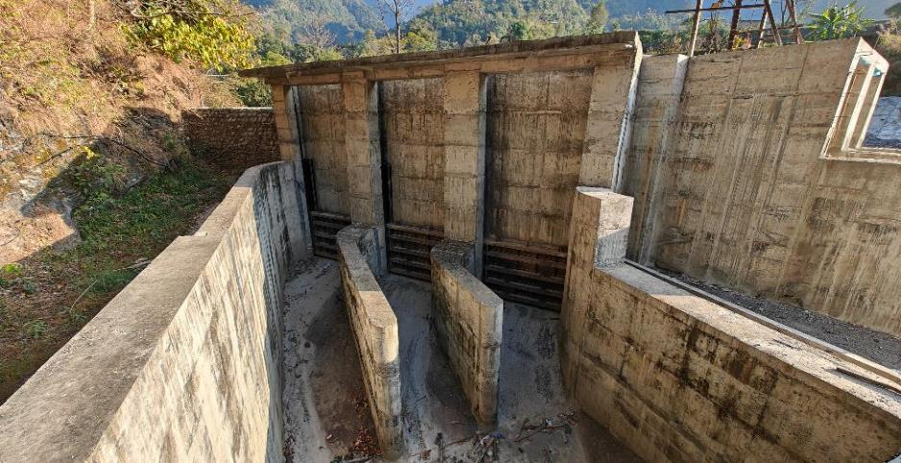

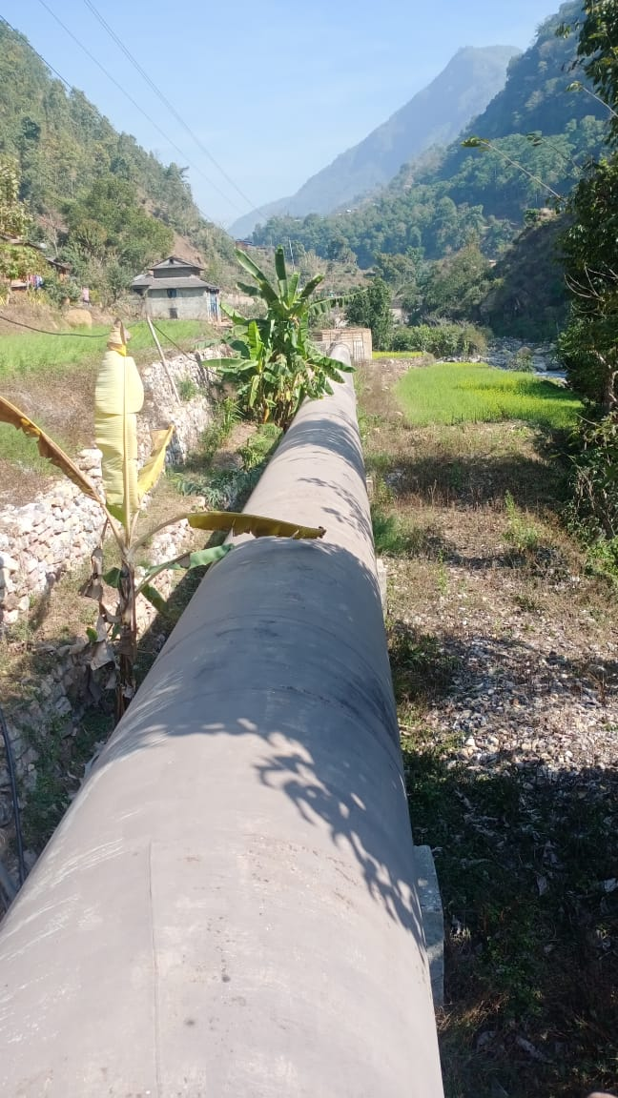
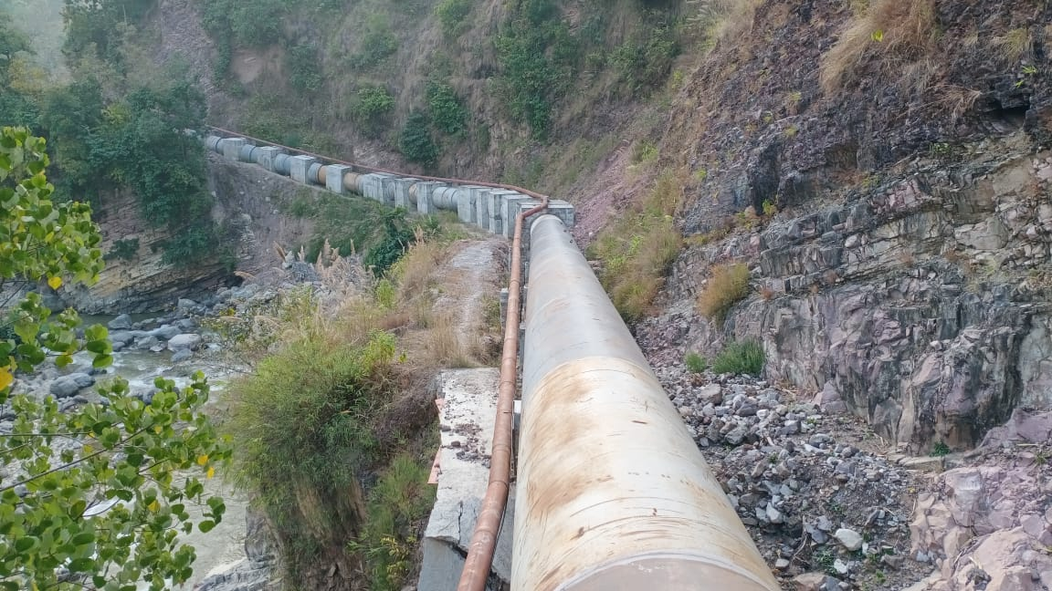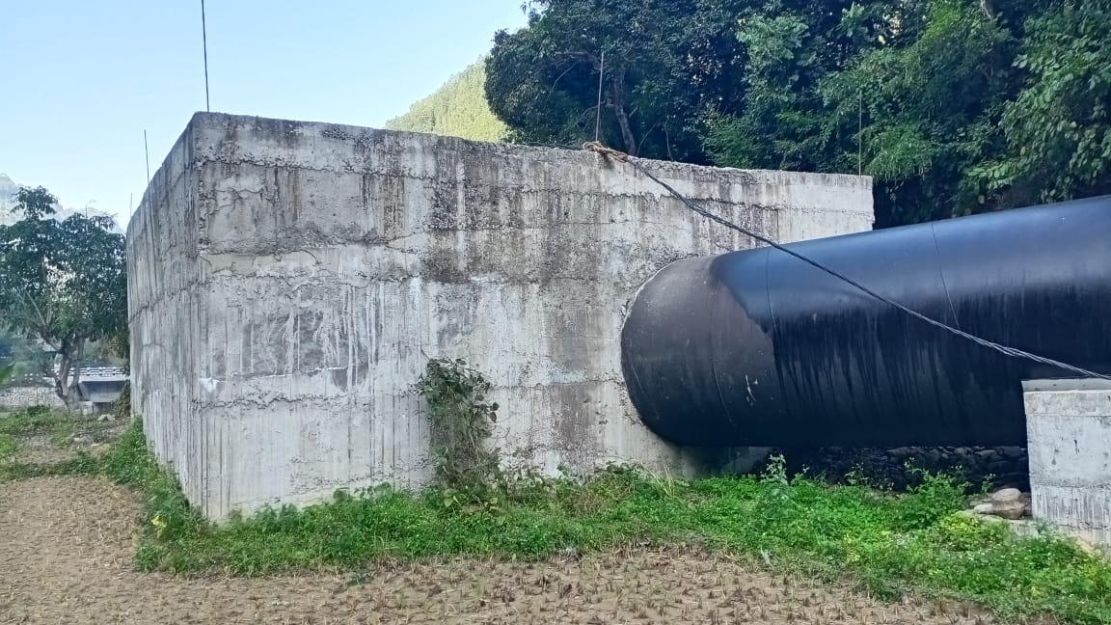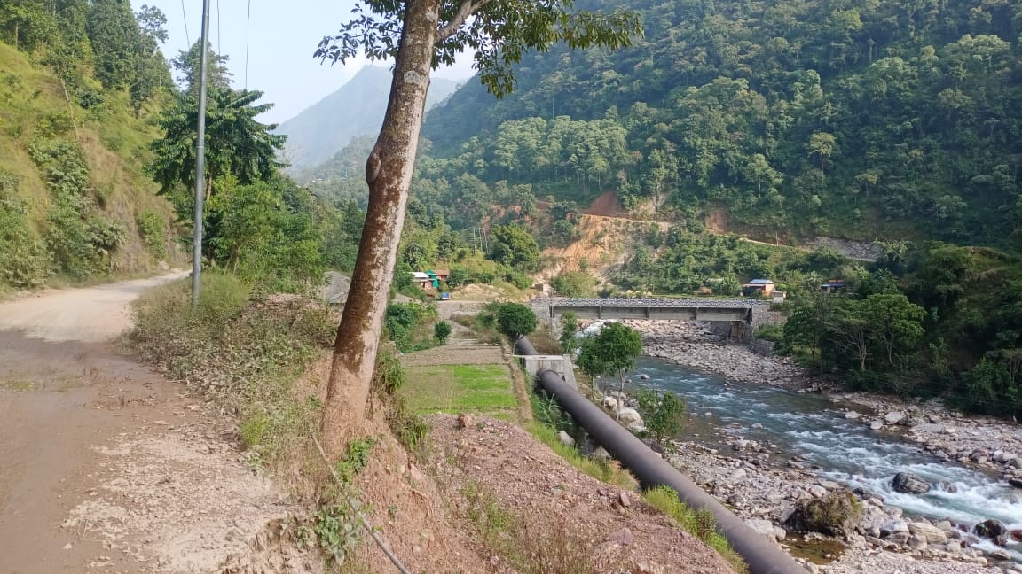

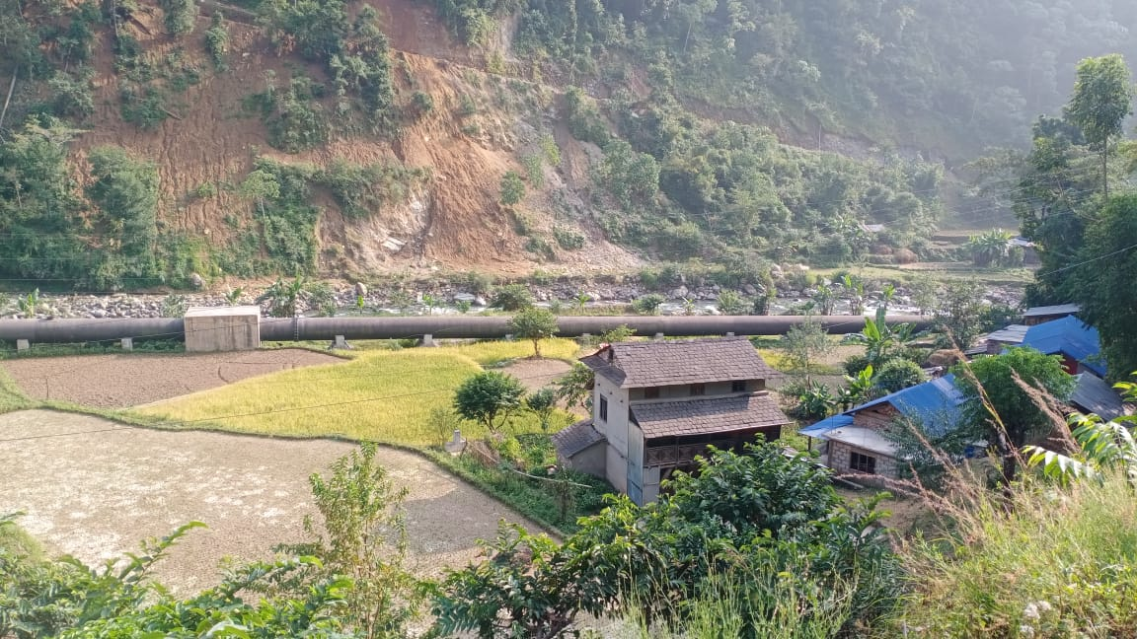
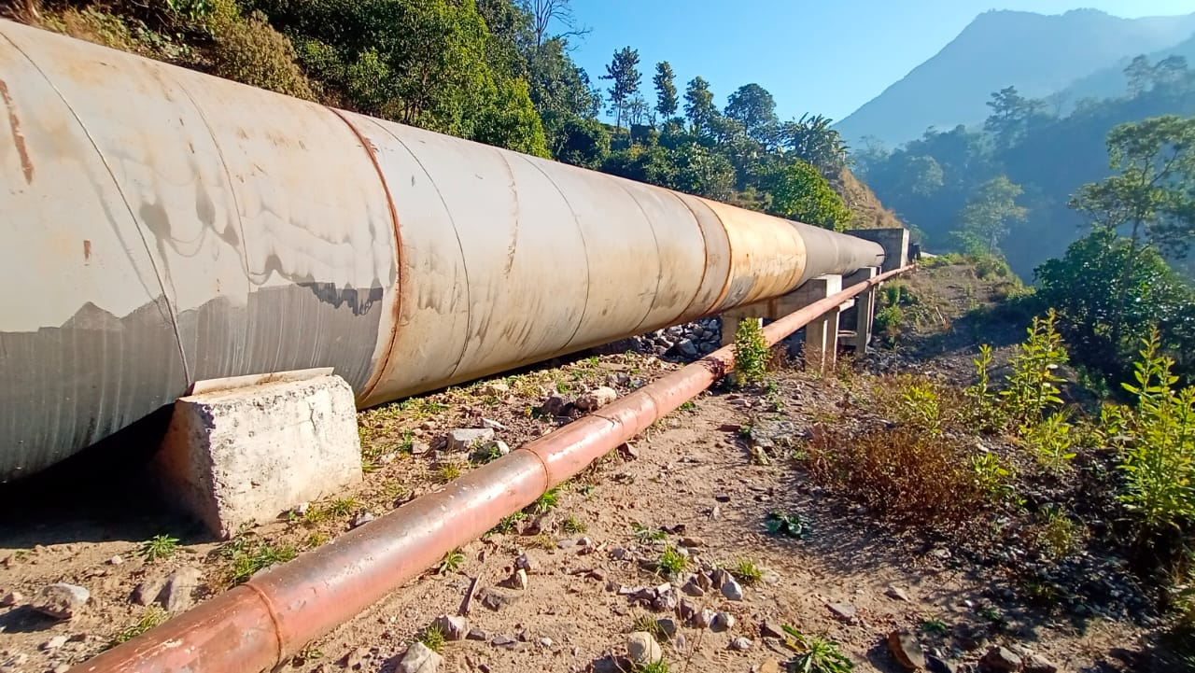
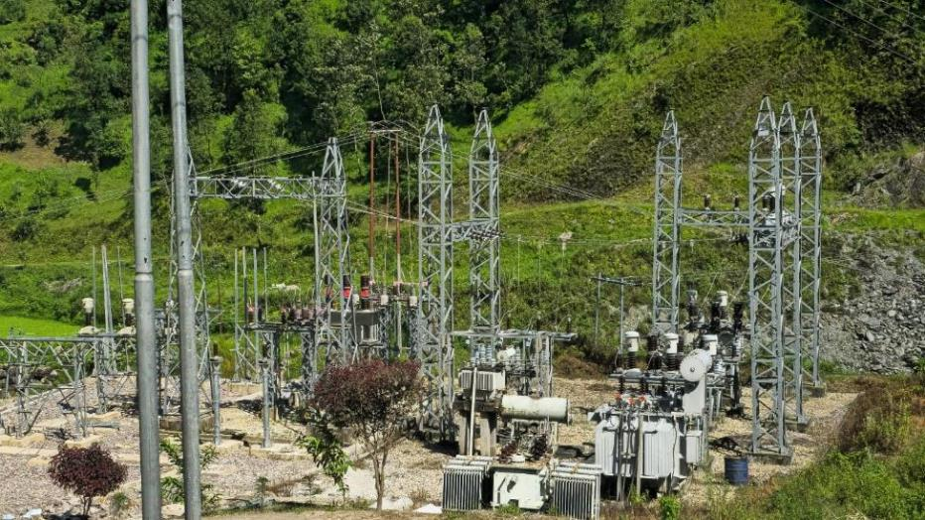

;dfKt

